Machine Description | A deliberately vulnerable lab machine for practicing web app exploits, privilege escalation, and post-exploitation to gain user and root access.
Target IP | 192.168.0.106
Vulnerability Name | • Weak Drupal CMS Configuration & Exposed Admin Password  • Privilege Escalation via Writable Backup Script (Cron Job)  • Remote Code Execution through Drupal PHP Extension Upload
Port / Service | TCP 80 / http
Severity | High (7.4)
Attack Vetor | CVSS:3.0/AV:L/AC:H/PR:N/UI:N/S:U/C:H/I:H/A:H
Proof of Concept (PoC) | STEP 1 – Nmap to find the IP of the target machine.  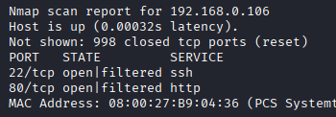  STEP 2 – Nmap Scan to discover open ports and Services  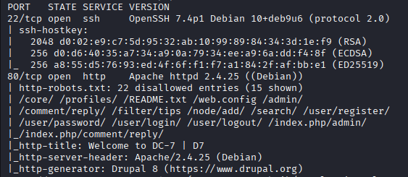  # nmap –p- -sC –sV $ip –open  STEP 3 - Found an install.php using wfuzz  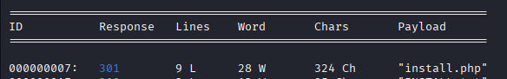  STEP 4 - found the exact version of Drupal by visiting the install.php  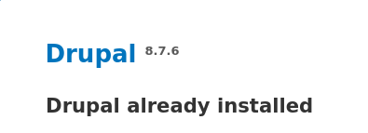  STEP 5 - There is a username on the front page of the website  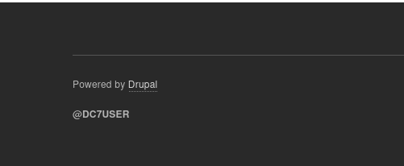  STEP 6 - Found a github repot with  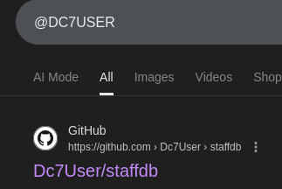  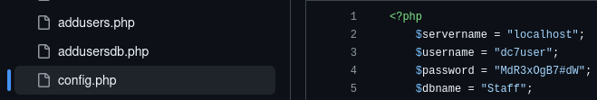  STEP 7 – Found a config file that has the username and password  STEP 8 - Logged in through SSH  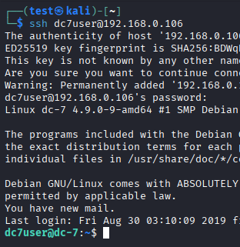  STEP 9 - There is a cron job running a backups.sh file with root  STEP 10 – As a dc7user we cannot change the script, only the root and  www-data can make changes, so we have to Downgrade our privillages.  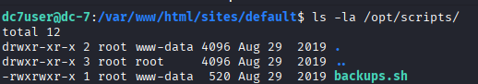  STEP 11 - But as a user we can change the drupal’s admin password  STEP 12 - We got admin access of the CMS.  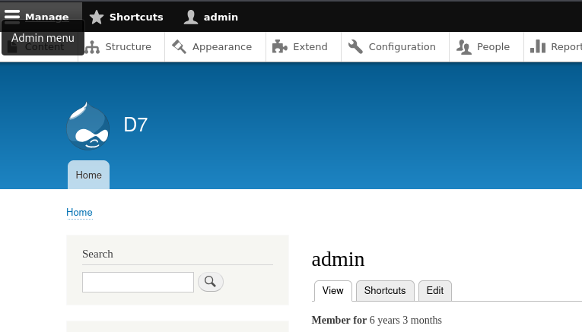  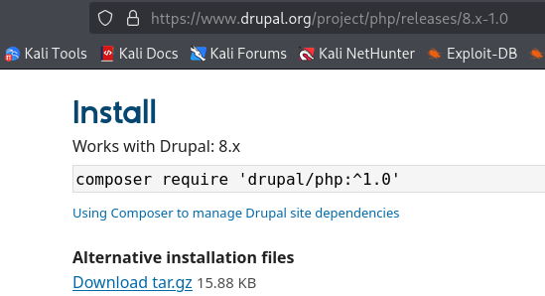  STEP 13 - There is a option to add PHP extension, download the extension of PHP for drupal 8.  STEP 14 – Upload the .gz file on to the drupal and click install.  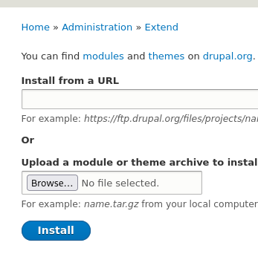  Step 15 – Check the box, scroll down and click install.  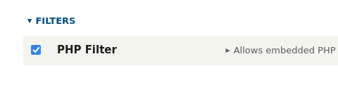  Step 16 – Inserted php code  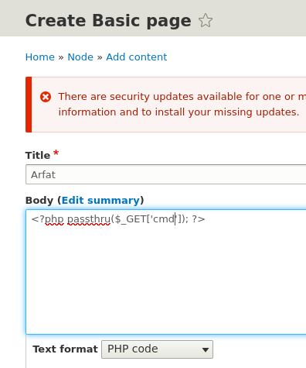  Step 16 – Save that page and you will have a new page and we have code execution through URL  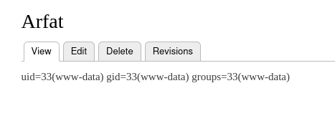  Step 17 – Now we can be www-data, got a shell using netcat  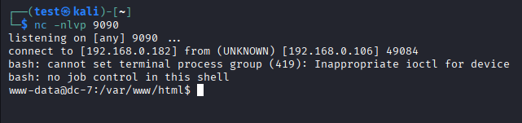  Step 18 – Append the backups.sh file  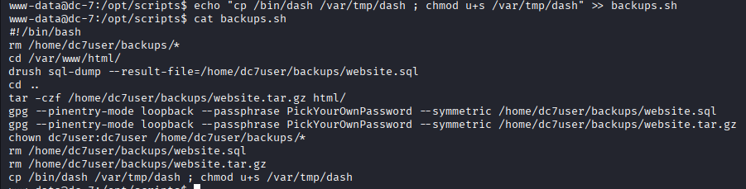  Step 19 – Now we just have to wait as soon as the backups.sh will execute the dash file will be in /var/tmp  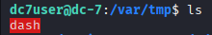  Step 20 – Execute the dash  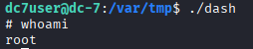  PROOF:  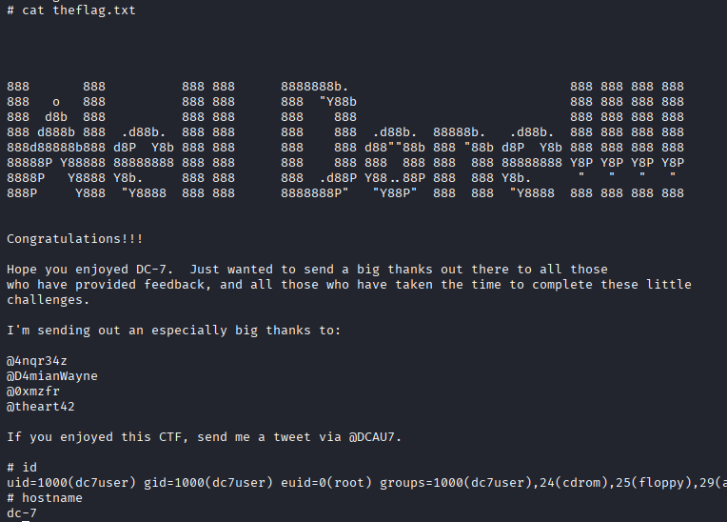
Remediation | • Remove passwords from config files and rotate all credentials.  • Disable the Drupal module upload unless needed.  • Lock down file permissions so normal users cannot modify scripts.  • Secure cron jobs – only root should be allowed to write backup scripts.  • Update Drupal to the latest version and remove exposed install.php.  • Use SSH key authentication instead of passwords.
Impact | • Attackers can log in as admin and fully control the website.  • They can run any command on the server (full control).  • They can become root (highest privilege) and take over the entire machine.  • Sensitive data, backups, configurations, and system files can be modified, stolen, or deleted.
References | https://ubuntu.com/tutorials/file-permissions  https://ubuntu.com/tutorials/file-permissions  https://www.redhat.com/sysadmin/cron-crontab  https://owasp.org/www-project-top-ten/

